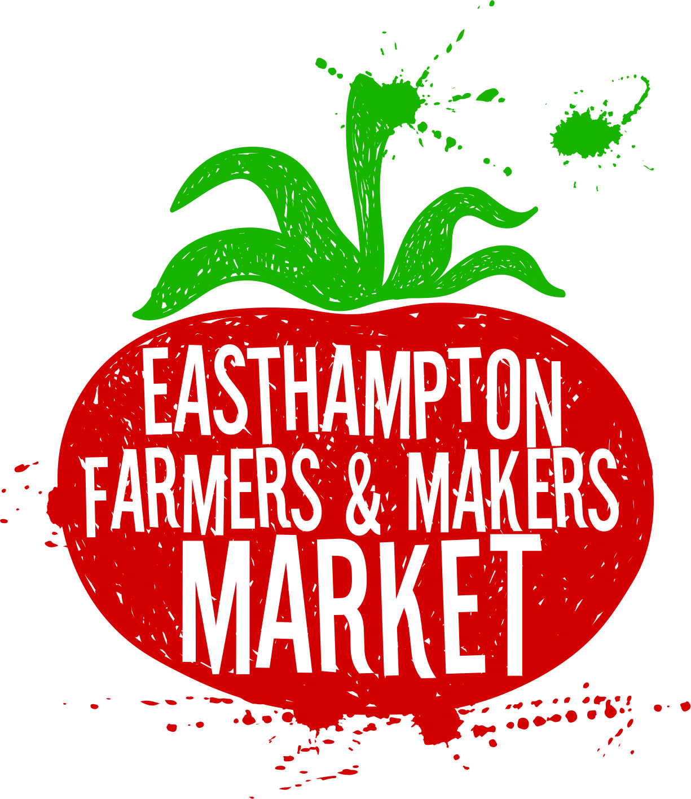
Easthampton Farmers and Makers Market
At 50 Payson Ave. Easthampton, MA
To be held on Saturdays 9 am-1 pm
May 13th, 2017 through October 28, 2017

Please fill out this form completely, sign, and return to P.O. Box 402 Easthampton, MA, 01027. Applications may also sent by email to: easthamptonfarmersmarket@gmail.com. Email applications are encouraged.
Name of farm or business: _______________________________________________
Owner(s)/Operator(s): _________________________________________________
Address of farm or business: ______________________________________________
Mailing address (if different): _____________________________________________
Phone number: ________________
Email: _________________________________
Farm or business website: _______________________________________________
List all products intended to sell at the market_________________________________________________________
_______________________________________________________________
Will you be attending for the FULL SEASON or PART SEASON? (Priority will be given to vendors participating for the full season). _____Full Season _______Part season
If part season, please list the dates you are interested in attending the market:_______
_______________________________________________________________

The market runs from May 13th to October 25th, for a total of 25 weeks. There are three payment options:
Pay In Full: $250, ($10 per week)
Two Payments: $150 each ($12 per week)
Drop in: $60 deposit, Deposit applied to 3 drop-in weeks at $20.00 per week, then $20.00 due at market each additional week.
Each vendor will be given a 10x10 space at the market. If a vendor wishes to have an extra 10x10ft space for a second tent, and additional fee will be added in the amount of half of the season cost. Ex. Two spots for a market, if paid in full would be $375. $250 + 125=$375
Please mail in your deposit or payment to Easthampton Farmers and Makers Market, P.O. Box 402, Easthampton, MA 01027 upon approval of application. Checks should be made out to: Easthampton Farmers and Makers Market with your farm/business name in the Memo.

